25.20: The ratio of the current at 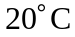 to that at the higher temperature is 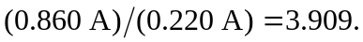Since the current density for a given field is inversely proportional to 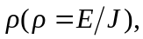 The resistivity must be a factor of 3.909 higher at the higher temperature.
